2: Country Flags Output Screenshot:

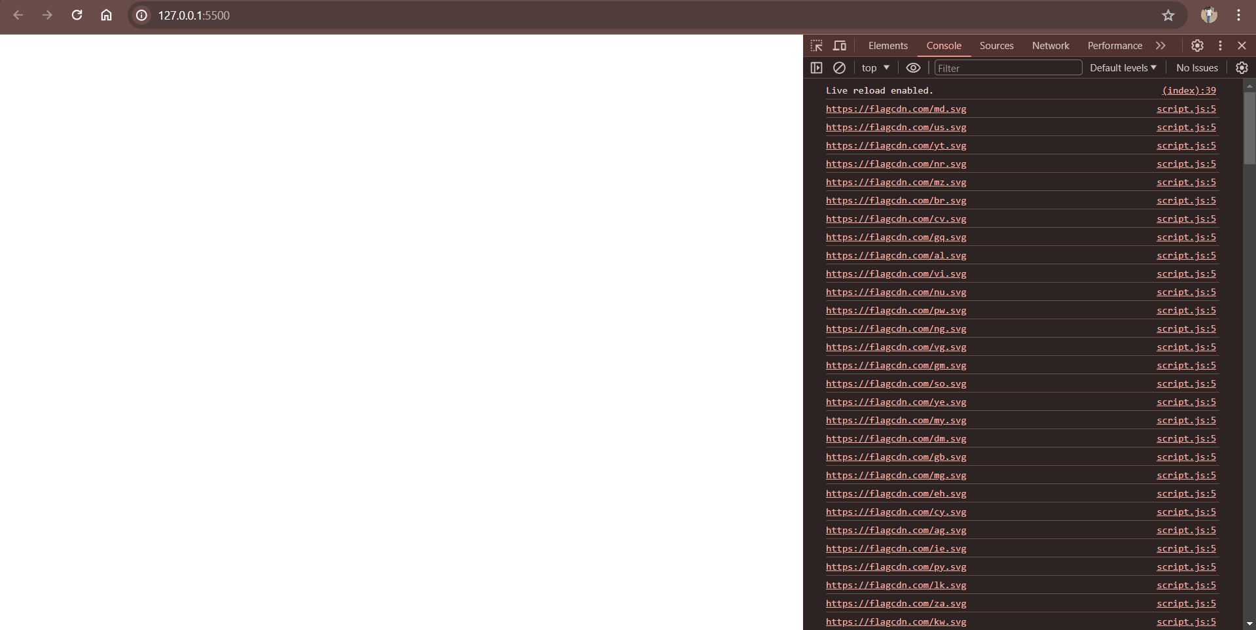

3: Names, Regions, Sub-region and Populations:

